ADITYA UNIVERSITY
Surampalem
Department of Artificial Intelligence & Machine Learning
DBMS CAPSTONE PROJECT
Project Documentation Report
- Project Title: University Academic Management System
Submitted by:
S.No | Student Name | Roll Number
1. | P.THANU SREE | 25B11AI946
2. | G.PARDHIVA SAI | 25B11AI346
3. | K. SANDEEP | 25B11AI524
4. | M. PADMAVATHI | 25B11AI717
Course: Database Management Systems (DBMS) Course Code: 2501IT05
Faculty Coordinator: T.Srinivasulu
Academic Year: 2026 Date of Submission:
GitHub Repository Link:

TABLE OF CONTENTS
TABLE OF CONTENTS 2
1. ABSTRACT 3
2. INTRODUCTION 3
2.1 Background 3
2.2 Purpose of the Database 3
3. PROBLEM STATEMENT 4
4. OBJECTIVES 4
5. TOOLS & TECHNOLOGIES USED 4
6. DATABASE DESIGN 6
6.1 Identified Entities 6
6.2 Entity Attributes 6
6.3 ER Diagram 8
6.4 Relationships & Cardinality 8
6.5 Relational Database Schema 9
6.6 Normalization 10
7. DATABASE IMPLEMENTATION 11
7.1 DDL — Database and Table Creation 11
7.2 Sample Data — DML 13
7.3 Constraints & Data Integrity 14
7.4 SQL Operations & Queries 19
7.5 Sample Outputs / Screenshots 21
8. MODULES & FUNCTIONALITIES 24
9. GITHUB REPOSITORY & TEAM RESPONSIBILITIES 24
10. ENHANCEMENTS & FUTURE IMPROVEMENTS 25
11. CONCLUSION 26
12. REFERENCES 27
APPENDIX 27
A. Complete SQL Script 27
B. Additional Screenshots / Outputs 27

ABSTRACT
The University Academic Management System is a centralized database system developed to manage university academic information efficiently. It stores and organizes information related to students, faculty, departments, courses, subjects, enrollment, examinations, and attendance.
The system reduces duplicate and inconsistent records and makes academic information easier to store, access, and manage. It uses SQL operations and database constraints to maintain data accuracy, consistency, and integrity.

2. INTRODUCTION

2.1 Background
Universities maintain a large amount of academic information such as student details, faculty details, courses, subjects, examinations, and attendance. Managing these records manually can result in duplicate or inconsistent data.
Maintaining attendance and examination records can also be time-consuming. Therefore, a centralized database system is useful for organizing academic information and making it easier to manage and retrieve.

2.2 Purpose of the Database
The main purpose of the database is to provide a centralized system for storing and managing university academic information.
The database helps to:
- Maintain student and faculty records.
- Manage departments, courses, and subjects.
- Store student enrollment information.
- Maintain examination and attendance records.
- Retrieve academic information quickly.
- Reduce duplicate data and improve accuracy.

3. PROBLEM STATEMENT
Managing university academic information manually can lead to duplicate and inconsistent records. Maintaining student and faculty information, enrollment, attendance, and examination records can be time-consuming.
Preparing academic results and reports can also become difficult when information is stored separately. Therefore, a centralized database is needed to store and manage academic information efficiently, accurately, and consistently.

4. OBJECTIVES.
- Objective 1: To develop a centralized database for university academic information.
- Objective 2: To maintain student and faculty records in an organized manne
- Objective 3: To manage departments, courses, subjects, and semesters efficiently.
- Objective 4: To record and manage enrollment, attendance, and examinations.
- Objective 5: To generate accurate academic results and reports quickly.

- 5. TOOLS & TECHNOLOGIES USED
Category | Tool / Technology Used
Database Server | PostgreSQL
Query / Admin Tool | pgAdmin
Front-end (if any) | None
Operating System | Windows
Version Control | GitHub

6. DATABASE DESIGN

6.1 Identified Entities
S.No | Entity Name | Description
1. | Student | Stores personal and academic information of students.
2. | Faculty | Stores information about faculty members.
3. | Department | Stores department details such as department name and HOD.
4. | Course | Stores information about courses offered by departments. Student-Student
5. | Subject | Stores subject, credits, semester, course, and faculty details.
6. | Enrollment | Stores student enrollment details for courses.

6.2 Entity Attributes
Entity | Attribute | Data Type | Key (PK/FK/—) | Attribute Type
Student |  | INT, VARCHAR, DATE, VARCHAR, VARCHAR, VARCHAR, VARCHAR, INT | PK, -, -, -, -, -, -, FK | Simple, Simple, Simple, Simple, Simple, Simple, Simple, Simple
  Student_ID, Student_Name, Date_of_Birth, Gender, Email, Phone, Address, Course_ID
Faculty | Faculty_ID, Faculty_Name, Email, Phone, Designation, Department_ID | INT, VARCHAR, VARCHAR, VARCHAR, VARCHAR, INT | PK, -, -, -, -, FK | Simple, Simple, Simple, Simple, Simple, Simple
Department | Department_ID, Department_Name, HOD_Name, Office_Location | INT, VARCHAR, VARCHAR, VARCHAR | PK, -, -, - | Simple, Simple, Simple, Simple
 | Course_ID, Course_Name, Duration, Department_ID | INT, VARCHAR, INT, INT | PK, -, -, FK | Simple, Simple, Simple, Simple
  Course
 |  | INT, VARCHAR, INT, INT, INT, INT | PK, -, -, -, FK, FK | Simple, Simple, Simple, Simple, Simple, Simple
  Subject
  Subject_ID, Subject_Name, Credits, Semester, Course_ID, Faculty_ID
Enrollment | Enrollment_ID, Student_ID, Course_ID, Enrollment_Date | INT, INT, INT, DATE | PK, FK, FK, - | Simple, Simple, Simple, Simple
Examination |  | INT, INT, INT, VARCHAR, DATE, INT | PK, FK, FK, -, -, - | Simple, Simple, Simple, Simple, Simple, Simple
  Exam_ID, Student_ID, Subject_ID, Exam_Type, Exam_Date, Total_Marks
Attendence |  | INT, INT, INT, DATE, VARCHAR | PK, FK, FK, -, - | Simple, Simple, Simple, Simple, Simple
  Attendance_ID, Student_ID, Subject_ID, Attendance_Date, Status

6.3 ER Diagram
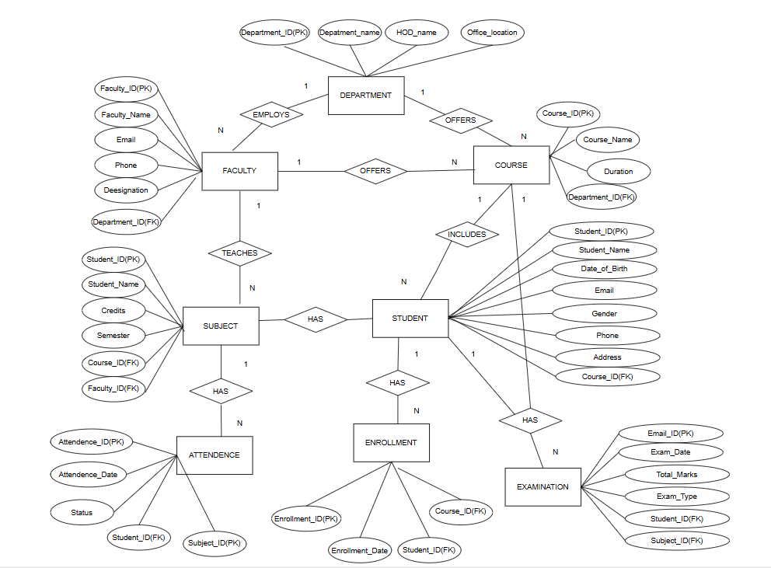

6.4 Relationships & Cardinality
Entity 1 | Relationship | Entity 2 | Cardinality (1:1 / 1:N / M:N)
Department | Has | Faculty | 1:N
Course | Has | Course | 1:N
Faculty | Teaches | Subject | 1:N
Student | Enrolls in | Course | N:1
Subject | Has | Examination | 1:N

6.5 Relational Database Schema
Table Name | Column Name | Data Type | PK/FK/— | Constraints
Department | Department_ ID, Department_Name, HOD_Name, Office_Location | INT, VARCHAR(100), VARCHAR(100), VARCHAR(100) | PK, -, -, - | PK, NOT NULL, UNIQUE, DEFAULT
Faculty | Faculty_ID, Faculty_Name, Email, Phone, Designation, Department_ID | INT, VARCHAR(100), VARCHAR(100), VARCHAR(15), VARCHAR(50), INT | PK, -, -, -, -, FK | PK, NOT NULL, UNIQUE, DEFAULT, FK
Course | Course_ID,Course_Name, Duration, Department_ID | INT, VARCHAR(100), INT, INT | PK, -, -, FK | PK, NOT NULL, UNIQUE, CHECK, FK
 | Student_ID, Student_Name, Date_of_Birth, Gender, Email, Phone, Address, Course_ID |  |  | PK, NOT NULL, UNIQUE, CHECK, DEFAULT, FK
  Student
  INT, VARCHAR(100), DATE, VARCHAR(10), VARCHAR(100), VARCHAR(15), VARCHAR(200), INT
  PK, -, -, -, -, -, -, FK
 | Subject_ID, Subject_Name, Credits, Semester, Course_ID, Faculty_ID | INT, VARCHAR(100), INT, INT, INT, INT | PK, -, -, -, FK, FK | PK, NOT NULL, UNIQUE, CHECK, FK
  Subject
Enrollment | Enrollment_ID, Student_ID, Course_ID, Enrollment_Date | INT, INT, INT, DATE | PK, FK, FK, - | PK, NOT NULL, FK, DEFAULT, UNIQUE
Examination | Exam_ID, Student_ID, Subject_ID, Exam_Type, Exam_Date, Total_Marks | INT, INT, INT, VARCHAR(50), DATE, INT | PK, FK, FK, -, -, - | PK, NOT NULL, FK, DEFAULT, CHECK
 |  | INT, INT, INT, DATE, VARCHAR(20) | PK, FK, FK, -, - | PK, NOT NULL, FK, DEFAULT, CHECK
  Attendance
  Attendance_ID, Student_ID, Subject_ID, Attendance_Date, Status

6.6 Normalization
UNF → 1NF → 2NF → 3NF
Normalization is used to reduce data redundancy and avoid insert, update, and delete anomalies in the University Academic Management System.
The database is normalized by separating data into related tables such as Student, Faculty, Department, Course, Subject, Enrollment, Examination, and Attendance.
Normalization steps:
1NF → 2NF → 3NF
1NF: Each attribute contains a single value and there are no repeating groups.
2NF: All non-key attributes depend completely on the primary key.
3NF: Non-key attributes depend only on the primary key and not on other non-key attributes.
Applicable Normal Form: 3NF
The database design follows Third Normal Form (3NF), which reduces duplicate data and improves data consistency and integrity. The relationships between tables are maintained using Primary Keys (PKs) and Foreign Keys (FKs).

7. DATABASE IMPLEMENTATION

7.1 DDL — Database and Table Creation
CREATE TABLE Department (
Department_ID INT PRIMARY KEY,
Department_Name VARCHAR(100) NOT NULL UNIQUE,
HOD_Name VARCHAR(100) NOT NULL,
Office_Location VARCHAR(100) DEFAULT 'Main Block'
);
CREATE TABLE Faculty (
Faculty_ID INT PRIMARY KEY,
Faculty_Name VARCHAR(100) NOT NULL,
Email VARCHAR(100) NOT NULL UNIQUE,
Phone VARCHAR(15) UNIQUE,
Designation VARCHAR(50),
Department_ID INT NOT NULL,
FOREIGN KEY (Department_ID) REFERENCES Department(Department_ID)
);
CREATE TABLE Course (
Course_ID INT PRIMARY KEY,
Course_Name VARCHAR(100) NOT NULL UNIQUE,
Duration INT NOT NULL CHECK (Duration > 0),
Department_ID INT NOT NULL,
FOREIGN KEY (Department_ID) REFERENCES Department(Department_ID)
);
CREATE TABLE Student (
Student_ID INT PRIMARY KEY,
Student_Name VARCHAR(100) NOT NULL,
Date_of_Birth DATE NOT NULL,
Gender VARCHAR(10) NOT NULL CHECK (Gender IN ('Male','Female','Other')),
Email VARCHAR(100) NOT NULL UNIQUE,
Phone VARCHAR(15) UNIQUE,
Address VARCHAR(200),
CHECK (Date_of_Birth < CURRENT_DATE)
);
CREATE TABLE Subject (
Subject_ID INT PRIMARY KEY,
Subject_Name VARCHAR(100) NOT NULL UNIQUE,
Credits INT NOT NULL CHECK (Credits BETWEEN 1 AND 6),
Semester INT NOT NULL CHECK (Semester BETWEEN 1 AND 8),
Course_ID INT NOT NULL,
Faculty_ID INT NOT NULL,
FOREIGN KEY (Course_ID) REFERENCES Course(Course_ID),
FOREIGN KEY (Faculty_ID) REFERENCES Faculty(Faculty_ID)
);
CREATE TABLE Enrollment (
Enrollment_ID INT PRIMARY KEY,
Student_ID INT NOT NULL,
Course_ID INT NOT NULL,
Enrollment_Date DATE NOT NULL DEFAULT CURRENT_DATE,
UNIQUE (Student_ID, Course_ID),
FOREIGN KEY (Student_ID) REFERENCES Student(Student_ID),
FOREIGN KEY (Course_ID) REFERENCES Course(Course_ID)
);
CREATE TABLE Examination (
Exam_ID INT PRIMARY KEY,
Student_ID INT NOT NULL,
Subject_ID INT NOT NULL,
Exam_Type VARCHAR(50) NOT NULL,
Exam_Date DATE NOT NULL DEFAULT CURRENT_DATE,
Total_Marks INT NOT NULL CHECK (Total_Marks BETWEEN 0 AND 100),
FOREIGN KEY (Student_ID) REFERENCES Student(Student_ID),
FOREIGN KEY (Subject_ID) REFERENCES Subject(Subject_ID)
);
CREATE TABLE Attendance (
Attendance_ID INT PRIMARY KEY,
Student_ID INT NOT NULL,
Subject_ID INT NOT NULL,
Attendance_Date DATE NOT NULL DEFAULT CURRENT_DATE,
Status VARCHAR(20) NOT NULL CHECK (Status IN ('Present','Absent')),
FOREIGN KEY (Student_ID) REFERENCES Student(Student_ID),
FOREIGN KEY (Subject_ID) REFERENCES Subject(Subject_ID)
);
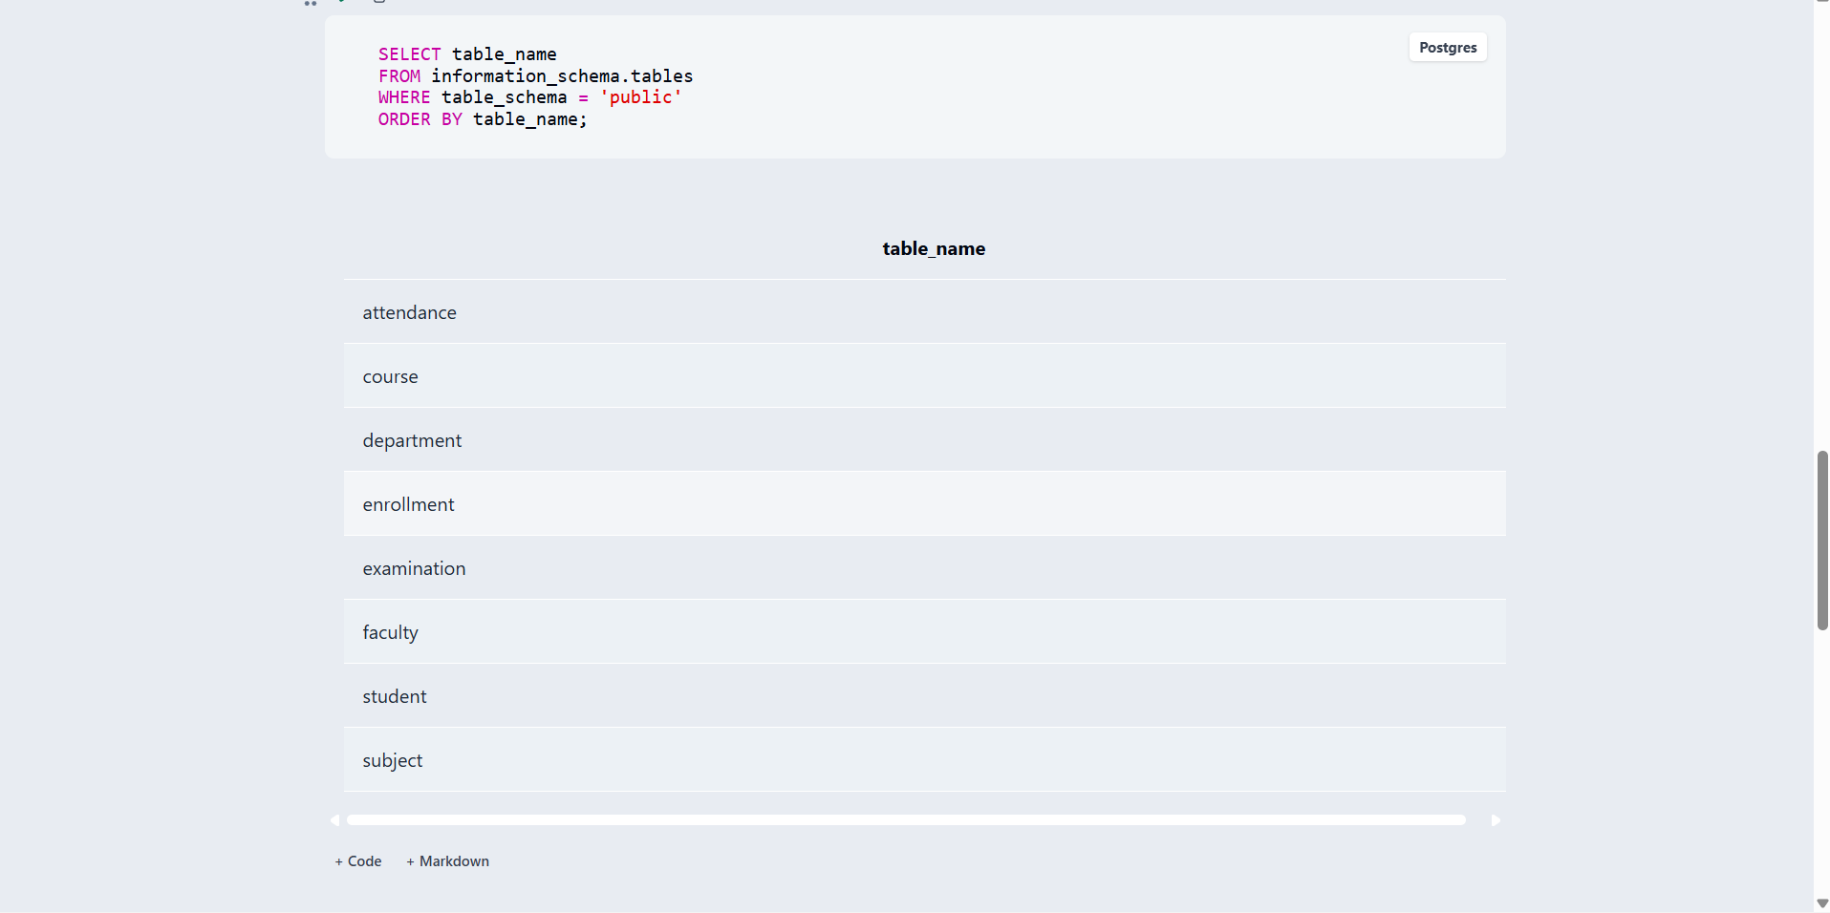

7.2 Sample Data — DML
Table | No. of Records | Sample Data / Screenshot Reference
Department | 3 | Computer Science, Artificial Intelligence, Electronics
Faculty | 4 | Anil Kumar, Swathi Reddy, Kiran Das, Meena Devi
Course | 3 | B.Tech CSE, B.Tech AI & ML, B.Tech ECE
Student | 5 | Rahul, Sneha, Arjun, Priya, Kavya
Subject | 5 | DBMS, Python Programming, Data Structures, Digital Electronics, Artificial Intelligence
Enrollment | 5 | Student-course enrollment records

7.3 Constraints & Data Integrity

Constraint / Validation | Applied On | Purpose | Evidence / Screenshot
PRIMARY KEY | All 8 tables | Ensures that each record has a unique identifier and prevents duplicate IDs. | 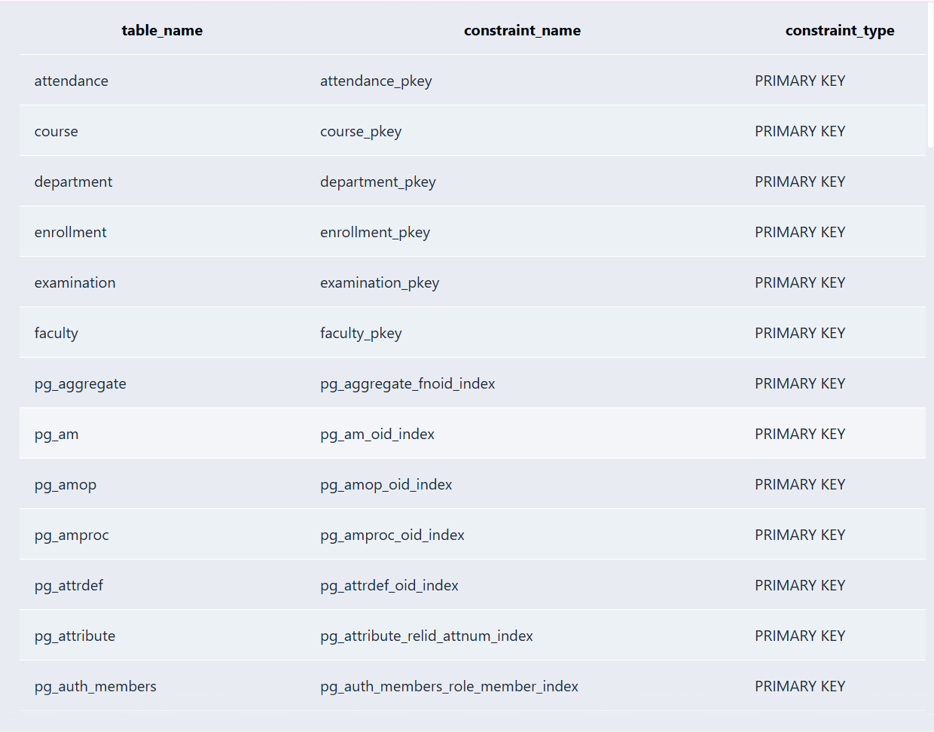
FOREIGN KEY | Faculty, Course, Student, Subject, Enrollment, Examination, Attendance | Maintains valid relationships between related tables and provides referential integrity. | 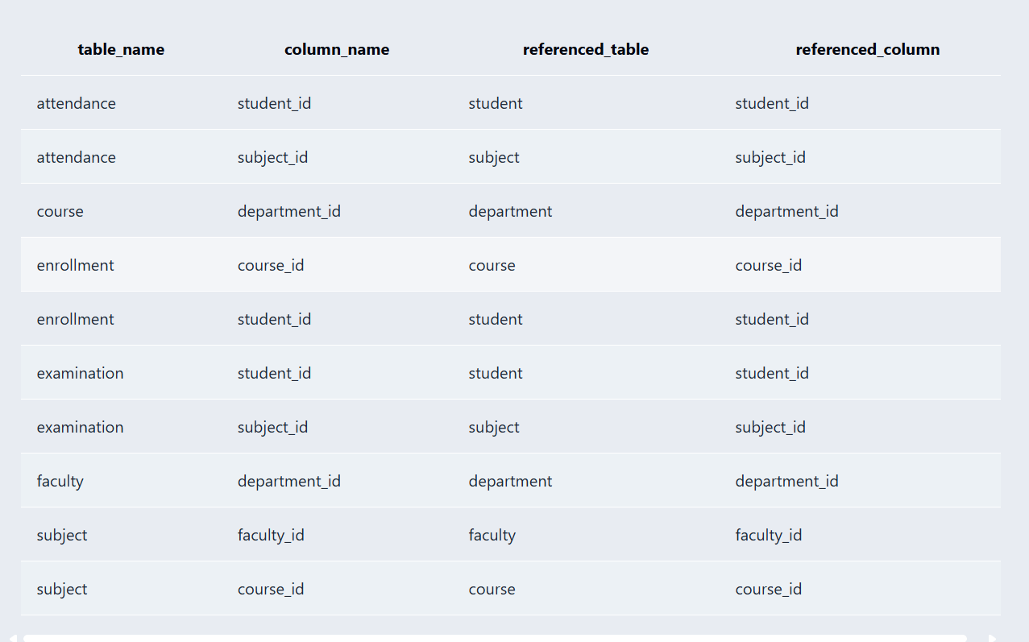
NOT NULL | Faculty_Name, Email, HOD_Name, Student_Name, Date_of_Birth, Course_ID, etc. | Prevents important fields from containing missing values. | 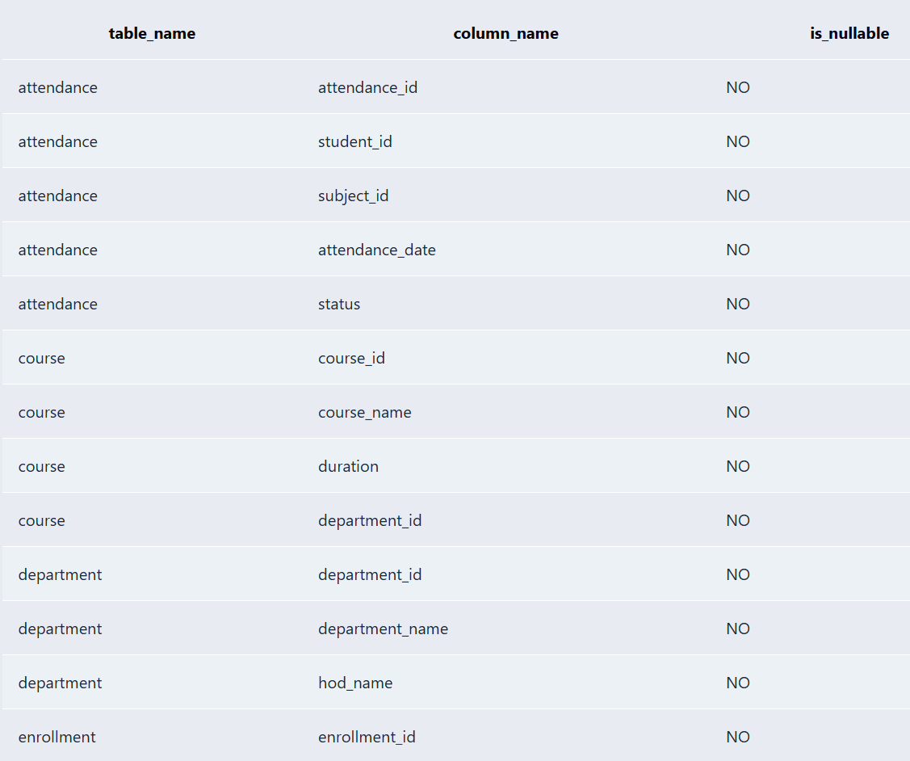
UNIQUE | Department_Name, Faculty Email, Faculty Phone, Course_Name, Student Email, Student Phone, Subject_Name | Prevents duplicate values in important fields. | 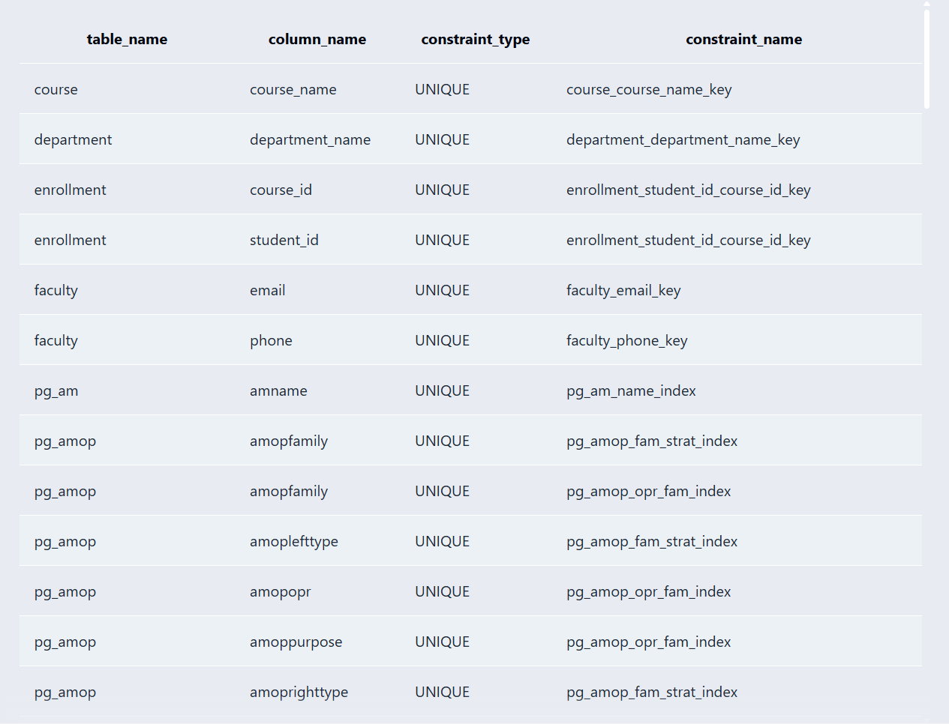
CHECK | Gender in Student | Allows only valid values: Male, Female, or Other. | 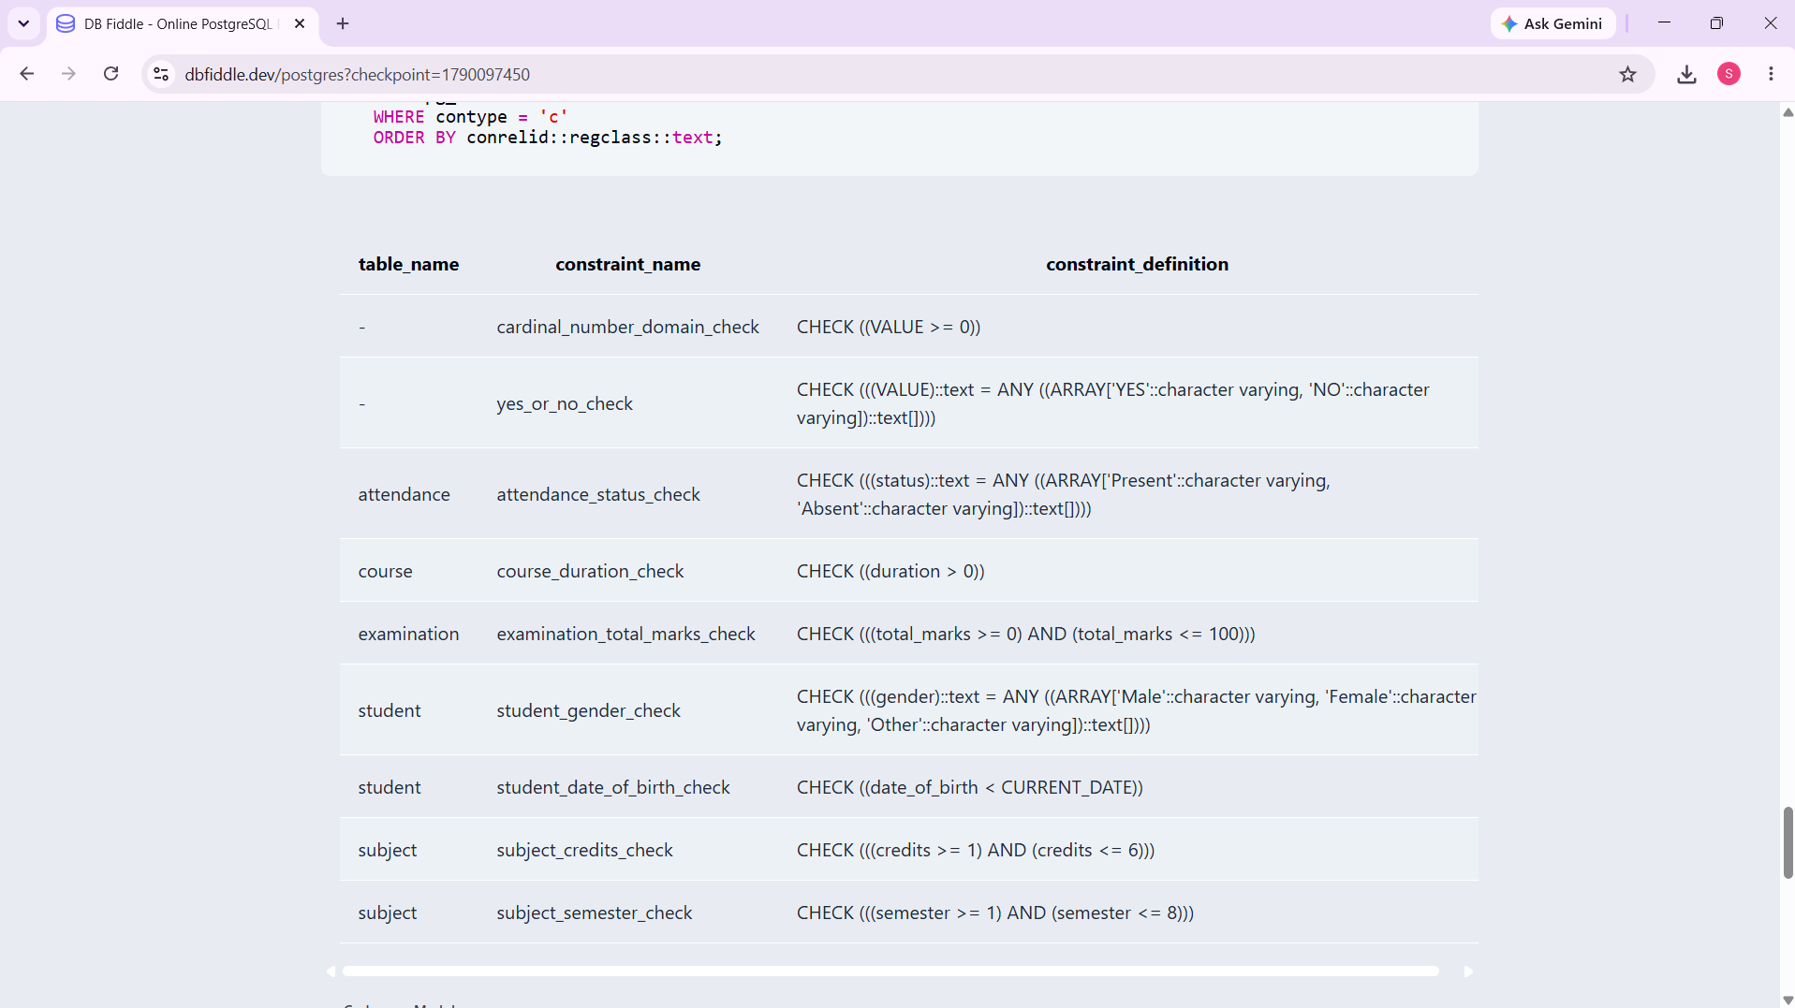
CHECK | Course Duration | Ensures that Duration is greater than 0. | 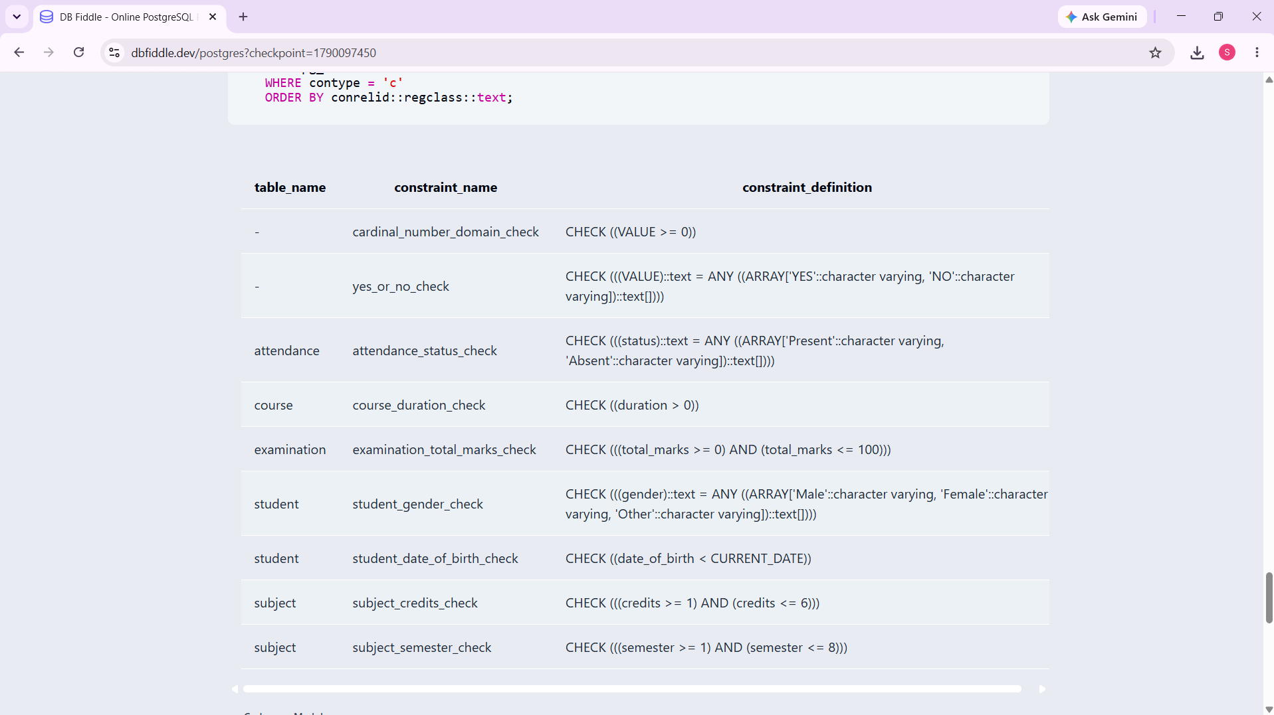
  DDL – CREATE TABLE

7.4 SQL Operations & Queries

S.No | Operation / Query | Purpose | SQL Query / Screenshot Ref.
1 | DDL – CREATE TABLE | Creates a new table and defines its structure. | CREATE TABLE Test_Table (Test_ID INT PRIMARY KEY, Test_Name VARCHAR(50) NOT NULL);
2 | DDL – ALTER TABLE | Adds a new column to an existing table. | ALTER TABLE Test_Table ADD Test_Date DATE;
3 | DDL – DROP TABLE | Removes a temporary table from the database. | DROP TABLE Test_Table;
4 | DML – INSERT | Adds a new department record. | INSERT INTO Department VALUES (104, 'Mechanical', 'Dr. Kumar', 'Block D');
5 | DML – UPDATE | Updates the HOD name of a department. | UPDATE Department SET HOD_Name = 'Dr. Anil Kumar' WHERE Department_ID = 104;
6 | DML – DELETE | Deletes a department record. | DELETE FROM Department WHERE Department_ID = 104;
7 | DQL – SELECT | Displays all student records. | SELECT * FROM Student;
8 | DQL – SELECT specific column | Displays subject names. | SELECT Subject_Name FROM Subject;
9 | DQL – WHERE | Displays students based on a condition. | SELECT * FROM Student WHERE Gender = 'Female';
10 | CRUD – CREATE | Adds a new student record. | INSERT INTO Student VALUES (406, 'Ravi', '2006-03-15', 'Male', 'ravi@gmail.com', '9000000006', 'Kakinada', 301);

7.5 Sample Outputs / Screenshots
Figure 1: Database and table creation in PostgreSQL/pgAdmin.
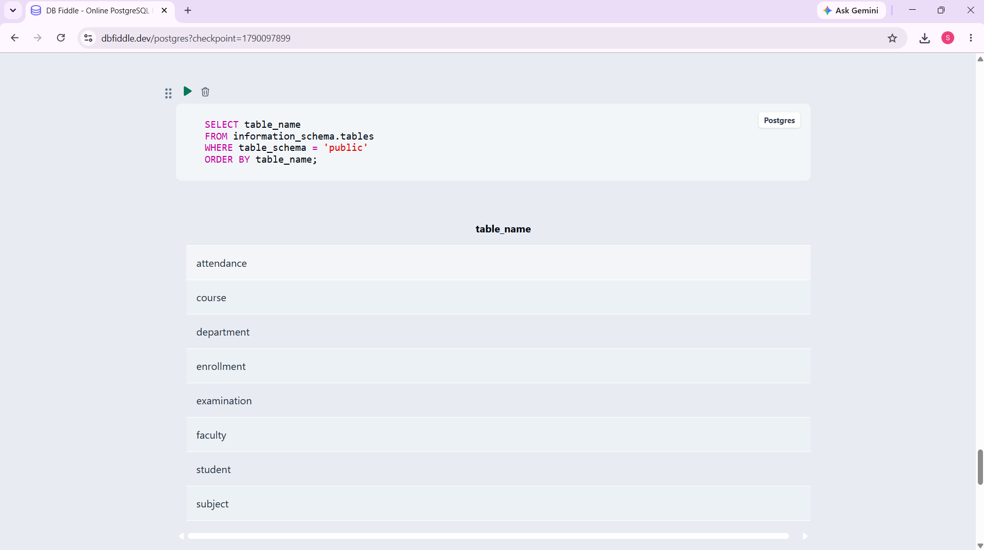
Figure 2: Sample data inserted into Department, Faculty, Course, Student, Subject, Enrollment, Examination, and Attendance.
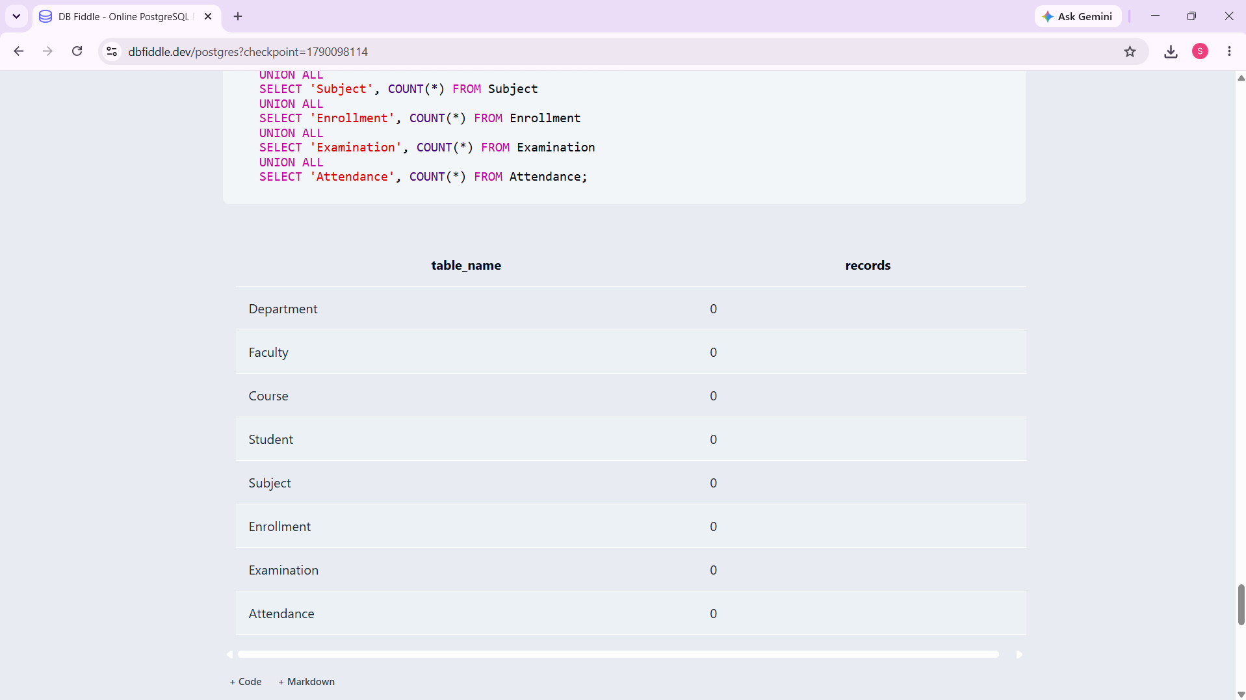
Figure 3: Details of Department
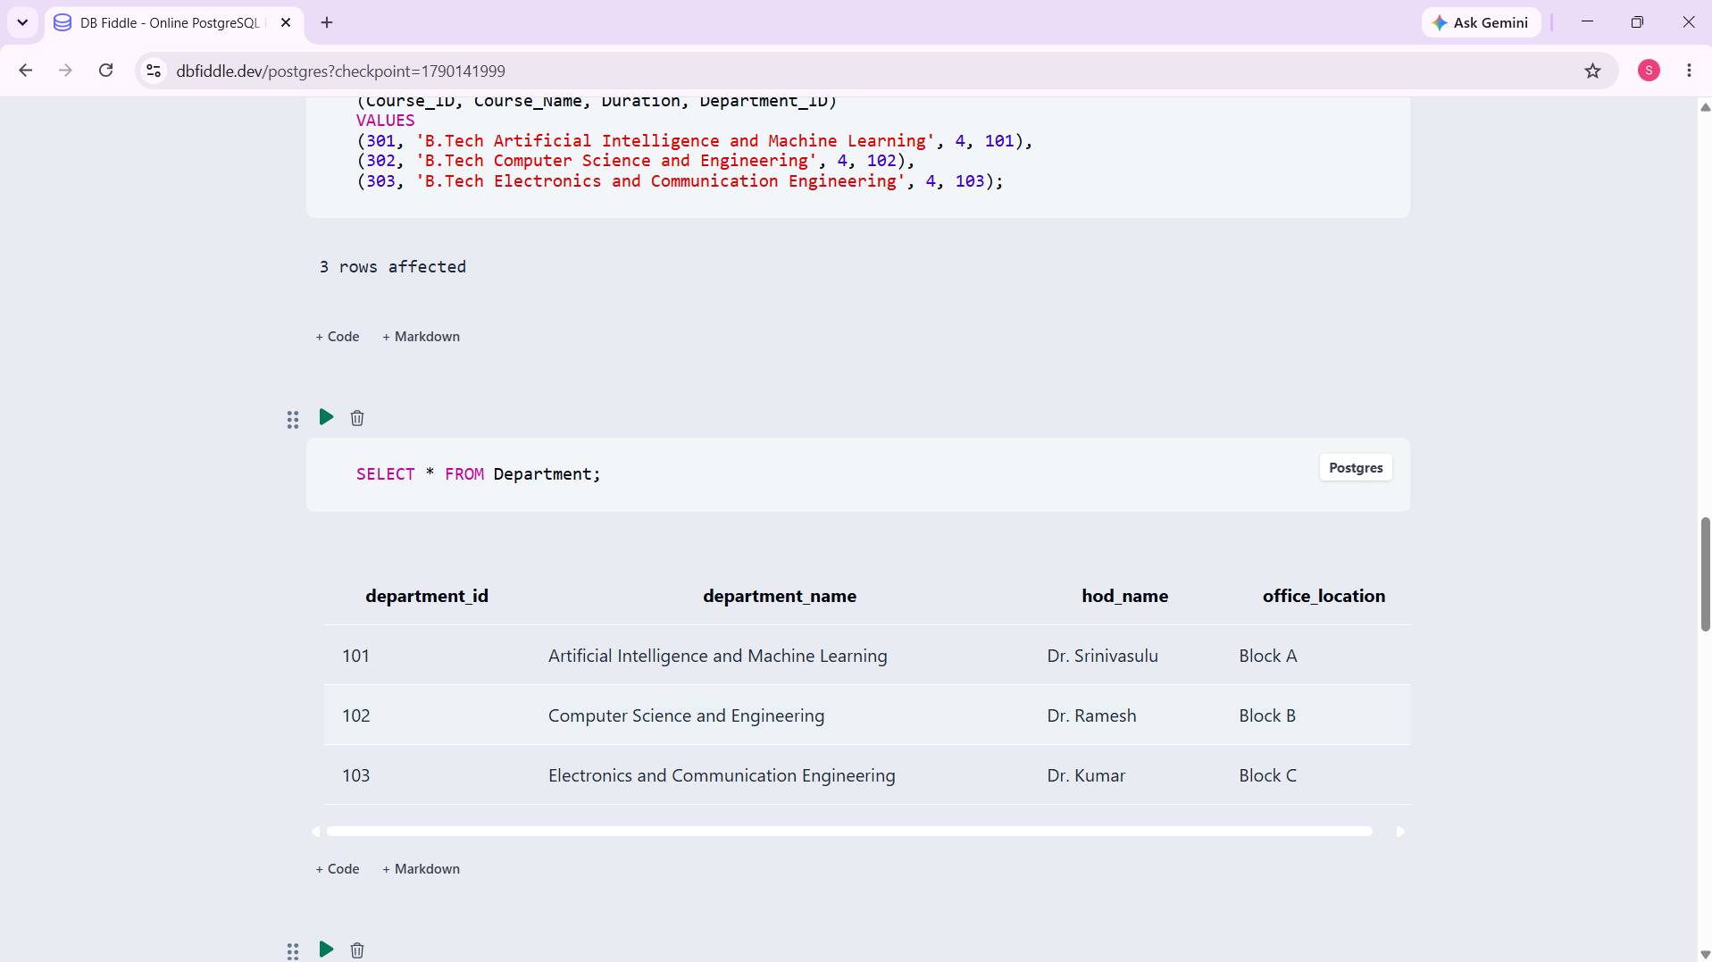
Figure 4: Details of course
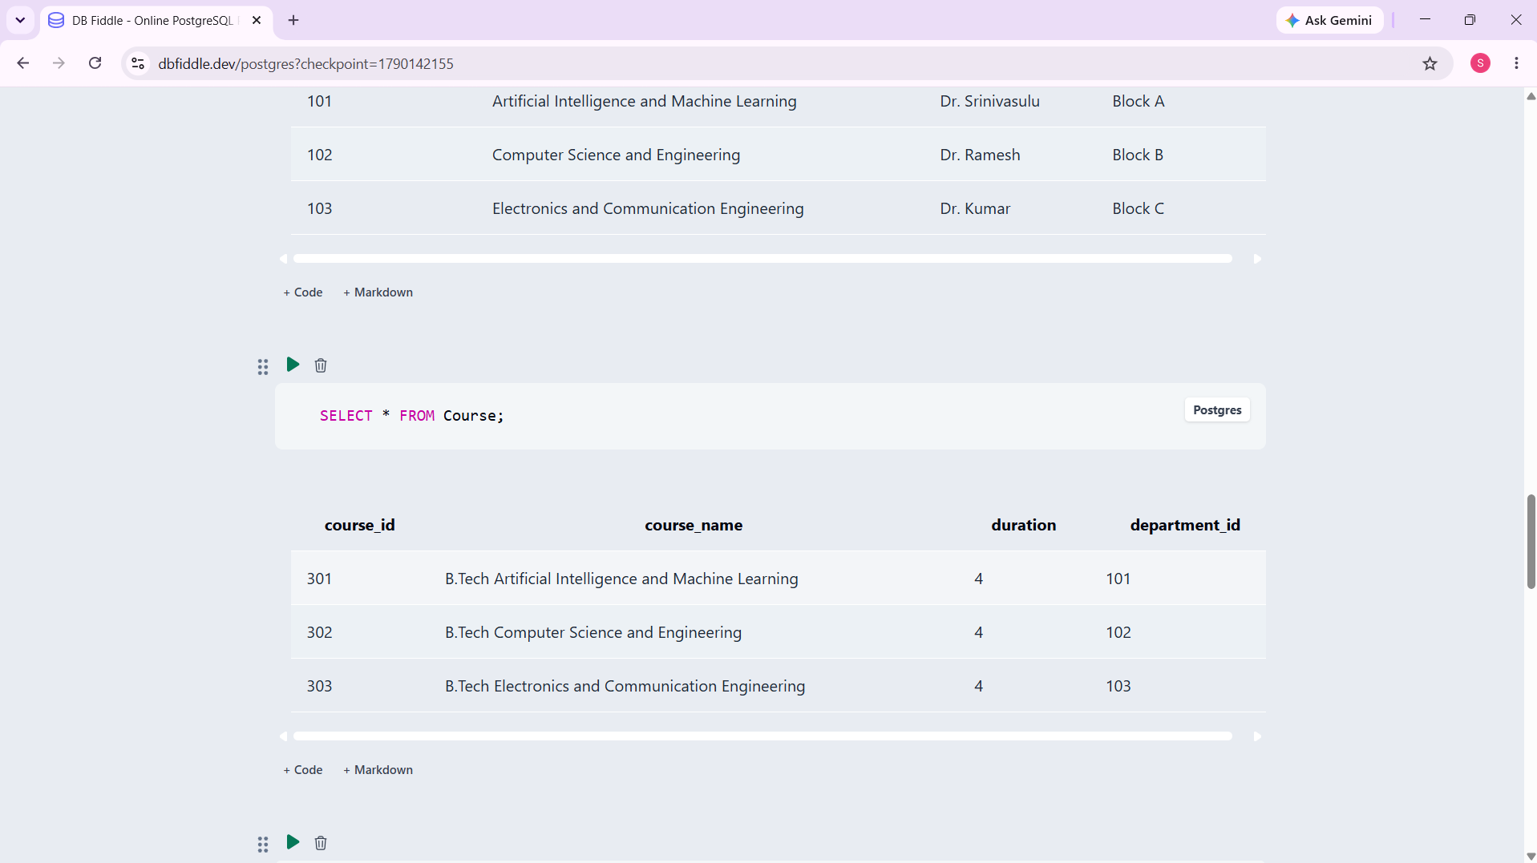

8. MODULES & FUNCTIONALITIES
S.No | Module Name | Functionality
 | Student Management | Stores and manages student details such as Student ID, name, date of birth, gender, email, phone, address, and course.
 | Faculty Management | Maintains faculty information including Faculty ID, faculty name, email, phone, designation, and department.
 | Department Management | Manages department details such as Department ID, department name, HOD name, and office location.
 | Course Management | Stores course information including Course ID, course name, duration, and associated department.
 | Subject Management | Manages subjects with Subject ID, subject name, credits, semester, course, and assigned faculty.
 | Enrollment Management | Records student enrollment in courses using Enrollment ID, Student ID, Course ID, and enrollment date.

9. GITHUB REPOSITORY & TEAM RESPONSIBILITIES
Repository Link:
Student Name | Roll Number | Role / Responsibility | Contribution Status
P.THANU SREE | 25B11AI946
G.PARDHIVA SAI | 25B11AI346
K.SANDEEP | 25B11AI524
M. PADMAVATH | 25B11AI717

10. ENHANCEMENTS & FUTURE IMPROVEMENTS
The University Academic Management System can be further enhanced to improve usability, security, performance, and scalability. The following improvements are planned for future development:
- User Interface Integration
A user-friendly web or desktop interface can be developed to allow students, faculty, and administrators to access the system easily.
- Authentication and Security
Login authentication and role-based access control can be implemented to ensure that only authorized users can access or modify academic information.
- Automated Reports
The system can generate automated reports for student records, course information, examinations, and attendance.
- Result Management
A result management module can be added to store marks, calculate grades, and generate examination results.
- Attendance Reports
Attendance percentage and detailed attendance reports can be generated for students and subjects.
- Performance Improvements
Indexing and query optimization can be introduced to improve database performance when the amount of academic data increases.
- Scalability
The database can be enhanced to support a larger number of students, faculty members, courses, subjects, and departments in the future.
These enhancements can make the University Academic Management System more efficient, secure, user-friendly, and suitable for real-world academic administration.

11. CONCLUSION
The University Academic Management System provides a centralized database for managing important academic information efficiently. The system manages students, faculty, departments, courses, subjects, enrollment, examinations, and attendance in an organized manner.
The project demonstrates important DBMS concepts including entity identification, ER design, relational database schema, Primary Keys, Foreign Keys, database constraints, sample data insertion, DDL, DML, DQL, CRUD operations, JOIN queries, aggregate functions, GROUP BY, and views.
Data integrity and consistency are maintained using Primary Key, Foreign Key, NOT NULL, UNIQUE, CHECK, and DEFAULT constraints. These constraints help prevent duplicate records, invalid values, missing important data, and incorrect relationships between tables.

12. REFERENCES
- PostgreSQL Documentation - https://www.postgresql.org/docs/
- PostgreSQL SQL Commands Documentation - https://www.postgresql.org/docs/current/sql.html
- pgAdmin Documentation - https://www.pgadmin.org/docs/
- Silberschatz, A., Korth, H. F., & Sudarshan, S. Database System Concepts. McGraw-Hill.
- Elmasri, R. & Navathe, S. B. Fundamentals of Database Systems. Pearson.

APPENDIX

A. Complete SQL Script

B. Additional Screenshots / Outputs
- Filter Subjects by Credits:
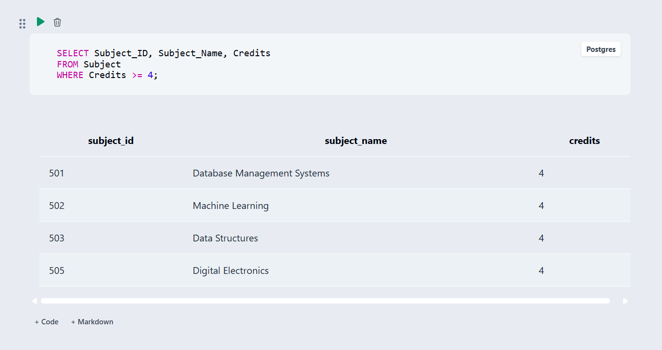
2. Find the highest subject credits :
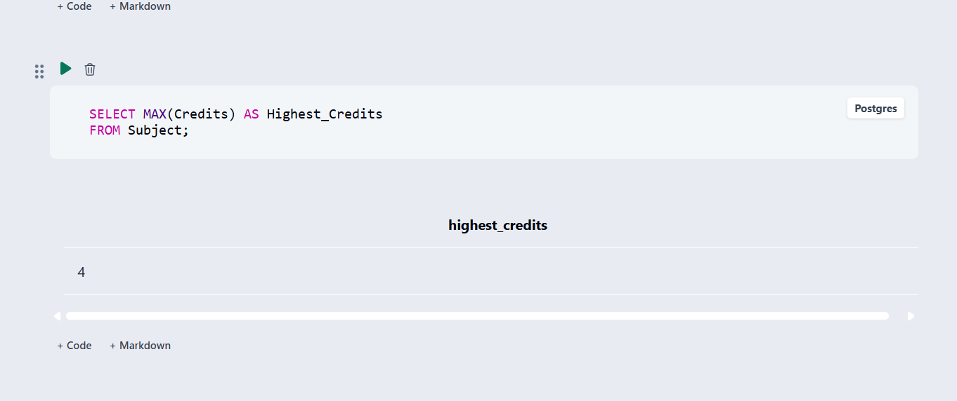
3. Subjects grouped by semester :
